**16:137:602:900C**

**Introduction to Cloud and Big Data Systems (Spring 2017)**

**Assignment 3**

*Maruthi Ayyappan – Aishwarya Gunde – Beethoven Plaisir*

1. **Provide the code that you have developed to run the proposed problem in Spark.**

Ans. Code included in the **codes.txt**.

1. **Provide the output of the Spark code execution, which shows, for each iteration, the number of measurements filtered and missing values, for each α value.**

Ans. For the following alpha values, the number of measurements filtered and missing values have been included in the below mentioned text files:

1. Alpha = 0.1; alpha1/**outalpha1.txt**
2. Alpha = 0.2; alpha2/**outalpha2.txt**
3. Alpha = 0.3; alpha3/**outalpha3.txt**
4. Alpha = 0.4; alpha4/**outalpha4.txt**
5. **Generate a heat map (or similar) of the wind speeds in the 2-dimensional space. Provide in your submission at least the heat map of the first and last iteration, for each α value.**

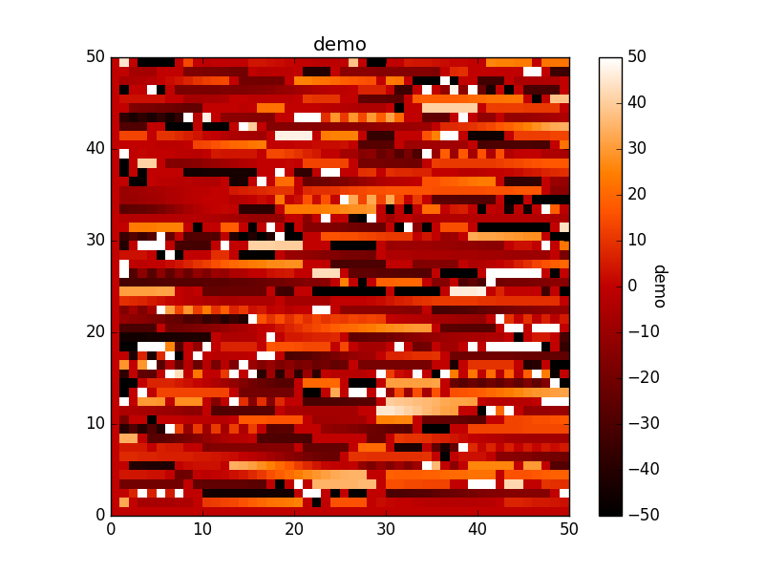

**Figure 1: Alpha = 0.1 Iteration -> 49**

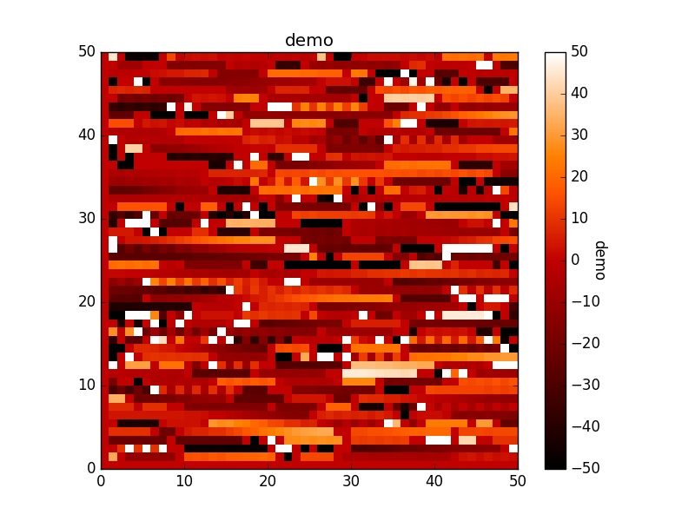

**Figure 2: Alpha = 0.2 Iteration -> 49**

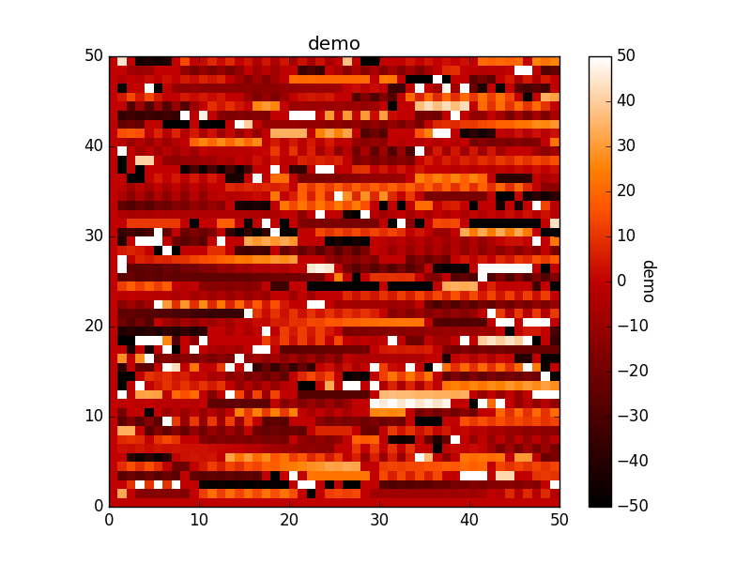

**Figure 3: Alpha = 0.3 Iteration -> 49**

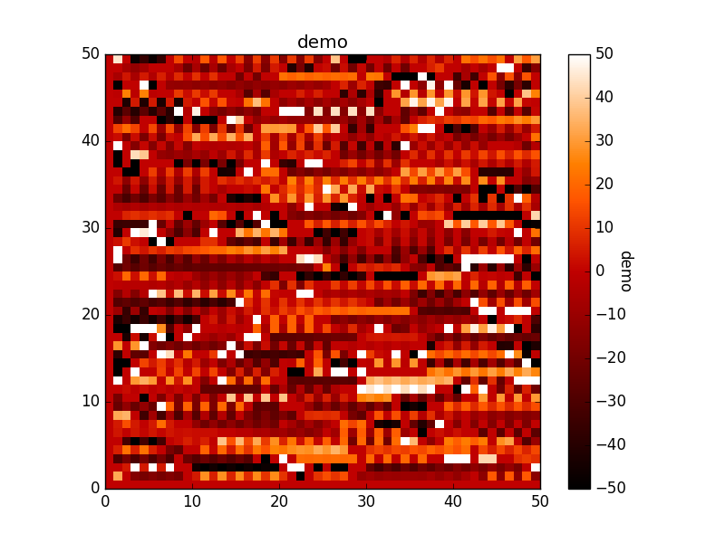

**Figure 4: Alpha = 0.4 Iteration -> 49**

(***NOTE:*** All the heat maps for specific alpha values and its respective iterations are stored in the folders alpha1 (α=0.1), alpha2 (α=0.2), alpha3 (α=0.3) and alpha4 (α=0.4).

1. **What is the impact of α value?**

Ans. (a) It seems that increase in **α** value increases the z value. For instance, the z-value for **α =** 0.1 is smaller than **α=**0.3 or 0.4. The **α** value only affects the *individual* z values in a direct proportion i.e. z value increases with increase in **α** value.

(b) However, based on observations done while iterating, it can be inferred that there’s random impact on the z values; both in positive and negative direction. Thus, we can say that there’s no direct proportion or relation of alpha values with the z magnitude when it comes to *multiple iterations.*

(c) Taking all these observations into consideration, we can say that increase in value of **α** increases the value of z whereas **α** values seem to have random impact on the iterations.

1. **Optional (for extra credit): Provide an animated gif showing the wind speeds in the bi-dimensional space over the 100 iterations, for each α value.**

Ans. For the following alpha values, animated gif showing the wind speeds in the bi-dimensional space over the 100 iterations have been shown in the below mentioned files:

1. Alpha = 0.1; Animated GIFS/**alpha1.gif**
2. Alpha = 0.2; Animated GIFS/**alpha2.gif**
3. Alpha = 0.3; Animated GIFS/**alpha3.gif**
4. Alpha = 0.4; Animated GIFS/**alpha4.gif**